Name___________________________________________ Date______________
U.S. History & Government Section____________

Cold War DBQ

This task is based on the accompanying documents (1-8). Some of these documents have been edited for the purpose of this task. The essay is designed to test your ability to work with historical documents. As you analyze the documents, take into account the source of each document and the author’s point of view.

Directions:

Analyze the documents
- Write a well-organized essay that includes an introduction and conclusion
- Use evidence from a minimum of four documents to support your position
- Do not simply repeat the contents of the documents
- Include specific related outside information

Historical Context
The years following World War II were dominated by the Cold War rivalry between the United States and the Soviet Union. The focus of this conflict centered around the opposing economic systems of capitalism and communism. As the Soviet Union sought to spread communism throughout the world, the United States adopted a policy of containment. This rivalry dominated political and military decision making from 1945-1991.

Task
Using information from the documents and your knowledge of social studies, write an essay in which you:
- Describe the two sides of the Cold War.
- Discuss several events of the Cold War or policies of either the U.S. or Soviet Union that shows the rivalry between the two nations in this period.

Part A- Short Answer [15 Points]
Directions: Analyze the documents and answer the questions that follow in the space provided.

Document 1
In 1946, Winston Churchill discussed the geographic division of Capitalism and Communism in Europe.

From Stettin in the Baltic to Trieste in the Adriatic, an iron curtain has descended across the continent. Behind that line lie all the capitals of the ancient states of Central and Eastern Europe… All these famous cities and populations around them lie in the Soviet sphere and all are subject in one form or another, not only to Soviet influence but to a very high and increasing measure of control from Moscow.

British Prime Minister Winston Churchill,
Speech at Fulton College, MO. March 1946

- What country influenced the governments of the nations on the eastern side of the Iron Curtain? [1]
_______________________________________________________________________________________________________________________________________________________________________________________

Document 2
I believe it must be the policy of the United States to support free peoples who are resisting attempted subjugation [domination] by armed minorities or by outside pressure. Should we fail to aid Greece and Turkey in this fateful hour, the effect will be far-reaching to the West. The seeds of totalitarian regimes are nurtured by misery and want. They spread and grow in the evil soil of poverty and strife. They reach their full growth when the hope of a people for a better life has died. Therefore, I propose giving Greece and Turkey $400 million in aid.

President Harry Truman
Speech to Congress, March 12, 1947

- Why is President Truman proposing to give money to Greece and Turkey? [2]
_________________________________________________________________________________________________________________________________________________________________________________________________________________________________________________________________________________________________________________

Document 3
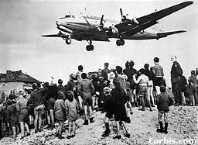

A group of Berliners watches the flight of a cargo plane carrying supplies from the Allied nations into Berlin during the Soviet blockade of 1948-1949

How did supplies reach the city of West Berlin during the blockade of 1948-49? [1]
____________________________________________________________________________________________________________________________________________________________________________________________________________________________________________________

Document 4
The parties agree that an armed attack against one or more of them in Europe or in North America shall be considered as an attack against them all. They agree that if such an armed attack occurs, each of them will assist the party or parties so attacked. Each will immediately take whatever action it considers necessary to restore and maintain the security of the North Atlantic area. It will, if necessary, use armed force.

Excerpt from North Atlantic Treaty 1948

4. What was the purpose of the NATO (North Atlantic Treaty Organization)? [2]
______________________________________________________________________________________________________________________________________________________________________________________________________________________________________________________________________________________________________________________________________________________________________________

Document 5
The United States wants, by means of [alliances] to secure a dominant position in the capitalist world. [They] offer the arms race as their main recipe for the preservation of peace! It is perfectly obvious that when nations compete to increase their military might, the danger of war becomes greater, not lesser. Capitalism will find its grave in another world war, should it unleash it.

Soviet Premier Nikita Khrushchev 1956

5. What danger does Soviet Premier Khrushchev feel is increased as a result of the arms race? [2]
_________________________________________________________________________________________________________________________________________________________________________________________________________________________________________________________________________________________________________________

Document 6
…[In] the last analysis our reason for being in South Vietnam… is a belief that this peninsula is an extremely strategic spot and that if it “went” communist all Southeast Asia and beyond would turn Red. This is the domino theory which has been used to justify every move in the cold war.

D.F. Fleming,
Professor of International Relations at Vanderbilt University

- According to Fleming, why was the United States involved in Vietnam? [2]
_________________________________________________________________________________________________________________________________________________________________________________________________________________________________________________________________________________________________________________

Document 7

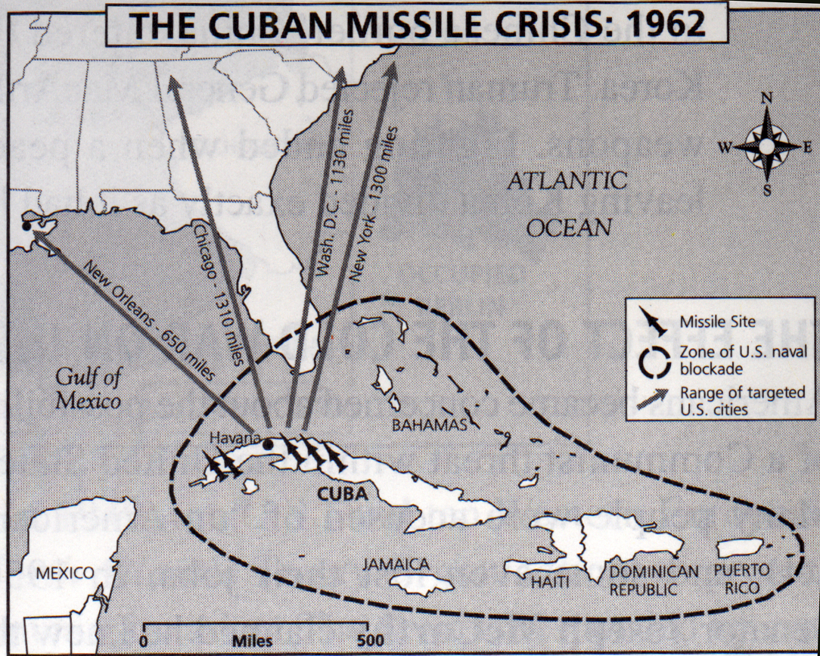

- What potential danger did the United States face as a result of the Soviet missile sites in Cuba? [2]
________________________________________________________________________________________________________________________________________________________________________________________________________________________________________________________________________________________________

Document 8

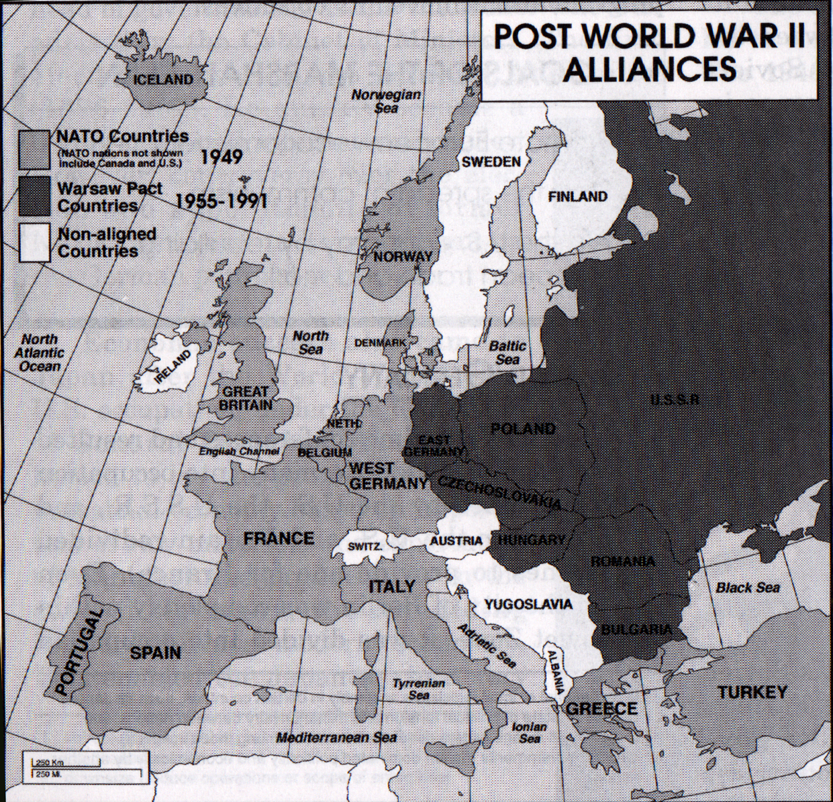

- According to the key, what two members of NATO are not shown on this map of Europe? [2]
________________________________________________________________________________________________________________________________________________________________________________________________________________________

- What alliance did the Soviet Union (USSR) form in response to the creation of NATO? [1]
________________________________________________________________________________________________________________________________________________________________________________________________________________________

PART III: DOCUMENT-BASED QUESTION

PART B− ESSAY

GENERIC SCORING RUBRIC

5
- Thoroughly addresses all aspects of the Task by accurately analyzing and interpreting at least four documents
- Incorporates information from the documents in the body of the essay
- Incorporates relevant outside information
- Richly supports the theme or problem with relevant facts, examples, and details
- Is a well-developed essay, consistently demonstrating a logical and clear plan of organization
- Introduces the theme or problem by establishing a framework that is beyond a simple restatement of the Task or Historical Context and concludes with a summation of the theme or problem

4
- Addresses all aspects of the Task by accurately analyzing and interpreting at least four documents
- Incorporates information from the documents in the body of the essay
- Incorporates relevant outside information
- Includes relevant facts, examples, and details, but discussion may be more descriptive than analytical
- Is a well-developed essay, demonstrating a logical and clear plan of organization
- Introduces the theme or problem by establishing a framework that is beyond a simple restatement of the Task or Historical Context and concludes with a summation of the theme or problem

3
- Addresses most aspects of the Task or addresses all aspects of the Task in a limited way, using some of the documents
- Incorporates some information from the documents in the body of the essay
- Incorporates limited or no relevant outside information
- Includes some facts, examples, and details, but discussion is more descriptive than analytical
- Is a satisfactorily developed essay, demonstrating a general plan of organization
- Introduces the theme or problem by repeating the Task or Historical Context and concludes by simply repeating the theme or problem

2
- Attempts to address some aspects of the Task, making limited use of the documents
- Presents no relevant outside information
- Includes few facts, examples, and details; discussion restates contents of the documents
- Is a poorly organized essay, lacking focus
- Fails to introduce or summarize the theme or problem

1
- Shows limited understanding of the Task with vague, unclear references to the documents
- Presents no relevant outside information
- Includes little or no accurate or relevant facts, details, or examples
- Attempts to complete the Task, but demonstrates a major weakness in organization
- Fails to introduce or summarize the theme or problem

0
- Fails to address the Task, is illegible, or is a blank paper

