Tuesday (10/6/20)

**//-//-//-//-//-//- //-//-//-//-//-//- //-//-//-//-//-//- //-//-//-//-//-//- //-//-//-**

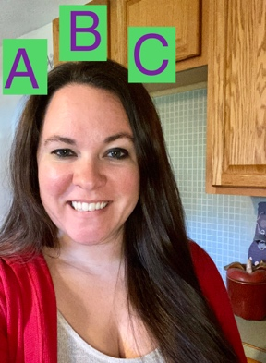

Literacy with Mrs. Acosta

* This week we are learning about the letter D. Check out the [D song](https://www.youtube.com/watch?v=Xf3MsJDsOLk) by PinkFong and this [Leapfrog letter sound song](https://www.youtube.com/watch?v=neItURLvyIQ&t=316s)
* Practice making the /d/ sound. You can hear them at the beginning of these words: dog-dip-door
* To listen to a story about Dinosaurs (Stomp Dinosaur Stomp) [click here](https://www.youtube.com/watch?v=IxiYyXIc3Co&list=PLdTivbS_XHlR9NGHLqVUxI6W7GoaL6C88&index=4).

Math with Miss Geary

* + Let’s learn about shapes! [Click here.](https://www.youtube.com/watch?v=OEbRDtCAFdU)
  + Parents- draw shapes and have your child trace over them! Repeat the shape name as child traces.
  + Let’s practice counting to 10! [Click here.](https://youtu.be/uGL7xYEVeaY)

Explore with Mrs. Abdo

* + Color BLUE & Square
  + Can you find a food that is BLUE send a picture to your teacher. Find a square and send a picture to your teacher.
  + [Learning color BLUE by Color Crew](https://www.youtube.com/watch?v=2Vuij41Ga_c)
  + [Learning about Squares Story Bots](https://www.youtube.com/watch?v=jOr2eRBluUs)

*Use below if you have NO technology *

Tuesday (10/6/20)

Literacy with Mrs. Acosta

* It’s letter Dd week: say the /d/ sound 5 times
* Find these D words in your house: dog, door, a drink (anything you can drink), dresser
* Do you have a favorite book at home? Read it with a family member

Math with Miss Geary

* + Practice looking at shapes and identifying what makes them different.
  + Draw a shape on a piece of paper and have your child repeat the name of the shape. Focus on circles, hearts, star, square and rectangle.
  + Practice counting to 10! You can hop while counting!

Explore with Mrs. Abdo

* Color Blue & Square
* Can you find a food that is BLUE send picture to your teacher. Find a square and send a picture to your teacher.
* Mom or dad draw a square for your child have them trace over it with his/her finger then with a crayon or marker. Parents give your child a choice of two - three crayons ask them to find the BLUE crayon then let them Color the square blue.