Family Engagement News
by: Cindi Rhoades

Happy Spring Families! The OCSD has a lot of great things going on to encourage families and the community to partner together to strengthen our district and help every child be successful. The age-old proverb is true: It takes a village to raise a child! Last month we held the Olean CSD Future Forum where about 50 people got together to discuss the Future of the OCSD. We also held the Black History Month tour at OHS and although it was a small turnout, those that attended found it engaging. Soon we will have our free dental clinic running for each of our 4 buildings! This means we will be offering every student the opportunity to get a free dental screening and tooth care products! They also have the opportunity to have a free cleaning, fluoride treatment, sealants and even dental x-rays if needed. Look for more information on this amazing opportunity coming home soon! The Southern Tier Symphony Concert will be on April 26th at 7:00 in the OHS Aud.
The District also held our first round of PreK Registrations & Screenings and had a good turnout. If you know of anyone with a preschoolers who is eligible to start PreK this Fall (turning 4 by December 1st) or to start Kindergarten (turning 5 by December 1st and not already enrolled in UPK), please encourage them to get their registrations & screenings done now and not wait until the end of summer. The registration portal is open: (www.oleanschools.org/registration). Call (716) 375-8998 with any questions. We will be holding more screening days so get your information in now to be included!
East View: East View held their Family Ice skating last month and had a great turnout (see pictures below) East View also had their monthly celebration of students following expectations and members from CUTCO came in to help them celebrate (see pictures below). The PTO has continued to remain busy planning events and new parents are always welcome to join the PTO. The next meeting will be on April 7th at 6:30 in Lauren Caya’s room. Upcoming events include: Parent/Teacher Conferences & Scholastic Book Fair on April 10th & 11th (so early dismissal for students), the EV Capital Project Presentation on 5/1 at 6:00 (EV Cafeteria), Kindergarten Concert on 5/9 at 1:30 and Grade 1 Concert on 5/15 at 1:30, PreK graduations, the end of the year Carnival on June 13th, & the 3rd Grade Moving Up Ceremony on June 25th at 9:30AM! Don’t forget there is NO school April 14th-18th for Spring break! School will resume on Monday April 21st!
Washington West: Washington West held a Title I Parent Meeting and a Masked Reader Night (see pictures below). About 24 students and their families attended this fun filled evening! This month is the “Husky Hunt” at Raymour & Flanigan on April 3rd from 5:30-6:30 PM, which is in just two days! Upcoming events include Parent/Teacher Conferences & Scholastic Book Fair on April 10th & 11th (so early dismissal for students) & the Scholastic Book Fair (April 10th until 5PM & 11th until 1 PM), the Glow Dance on April 25th from 5:00-6:30 PM, spring concerts, PreK graduation, 3rd grade moving up ceremonies and the annual Spring Break Party! Don’t forget there is NO school April 14th-18th for Spring break! School will resume on Monday April 21st!
OIMS: Upcoming events will include Parent/Teacher Conferences on April 10th & 11th (so early dismissal for students), the 4th/5th Grade Concert on April 30th @ 6:30 PM (OHS Aud), their Family Literacy Night, and Upcoming 4th Graders Family Orientation to OIMS. All the current third graders from both East View and Washington West came to visit OIMS in March but we are currently planning the big Family Orientation Night as well! Don’t forget there is NO school April 14th-18th for Spring break! School will resume on Monday April 21st!
OHS: OHS held their Winter Sports Banquet last month and had about 100 students/families participate! (see pictures below). The 3rd annual OCSD vs. Police Basketball Game was held on March 12th, with more than 500 people coming to watch the OCSD staff beat the OPD 62-56! Cheerleaders for both sides were provided by student volunteers. (see pictures). Upcoming Events include the Spring Musical this weekend on April 4th & 5th at 7:00PM in the Auditorium, just a few days away! And of course don’t forget the huge Graduation Ceremony in June!
Special Education: The Special Education Department held its Spring Junior/Senior/Parent Night to assist with applying for ACCES-VR services. 80% of our eligible seniors have taken advantage of this. If you are a student with a disability and are a Junior or Senior, and you haven’t yet filled out your paperwork for ACCES-VR (transitional services), you still have time to do this! Please contact Cindi Rhoades at (716) 375-8031.They also held a free workshop through Parent Network on “Parents & Family Engagement through the FBA and BIP Process”.

SAVE THE DATES:
April 3rd: WW Husky Hunt- 5:30-6:30 PM @Raymour & Flanigan
April 4th & 5th: OCSD Musical –7:00 PM @ OHS Auditorium
April 9th: Capital Project Presentation- 6:00 PM WW Elementary
April 10th & 11th: Parent Teacher Conferences at EV, OIMS & WW (early dismissal for students grades PreK-7th grade)
April 14th-18th: NO SCHOOL- Spring Break
April 25th: WW Glow Dance 5:00-6:30 PM
May 1st: Capital Project Presentation-6:00PM EV Cafeteria
May 6th: Capital Project Presentation- 5 PM OIMS LGI room
May 9th: EV Kindergarten Concert- 1:30PM EV Cafeteria
May 15th: EV Grade 1 Concert- 1:30PM EV Cafeteria
May 20th: Public Vote 7AM-9PM- OIMS Music Suite
May 26th: NO SCHOOL- Memorial Day
June 13th: EV Carnival- 5:30-7:00PM at EV
June 25th: EV 3rd Grade moving up Ceremony- 9:30.
Did you know that there are plenty of resources available on our website? Just go to www.oleanschools.org and under the Community Schools you will find the Family Engagement Page. Here you will find plenty of resources and we will continue to update these. There is also a Calendar and a Community Events section that includes both things through the school and a section for events out in the community for families to participate in! New items are listed almost daily so check it out. We also added a section for Newsletters that will be posted monthly. Also, there is a family resource page for each of our buildings through Parent Square. If you know of an event in the community and don’t see it listed there, feel free to contact Cindi Rhoades at (716) 375-8031 or crhoades@oleanschools.org and fill me in.
Enjoy the pictures below of some events we’ve had!
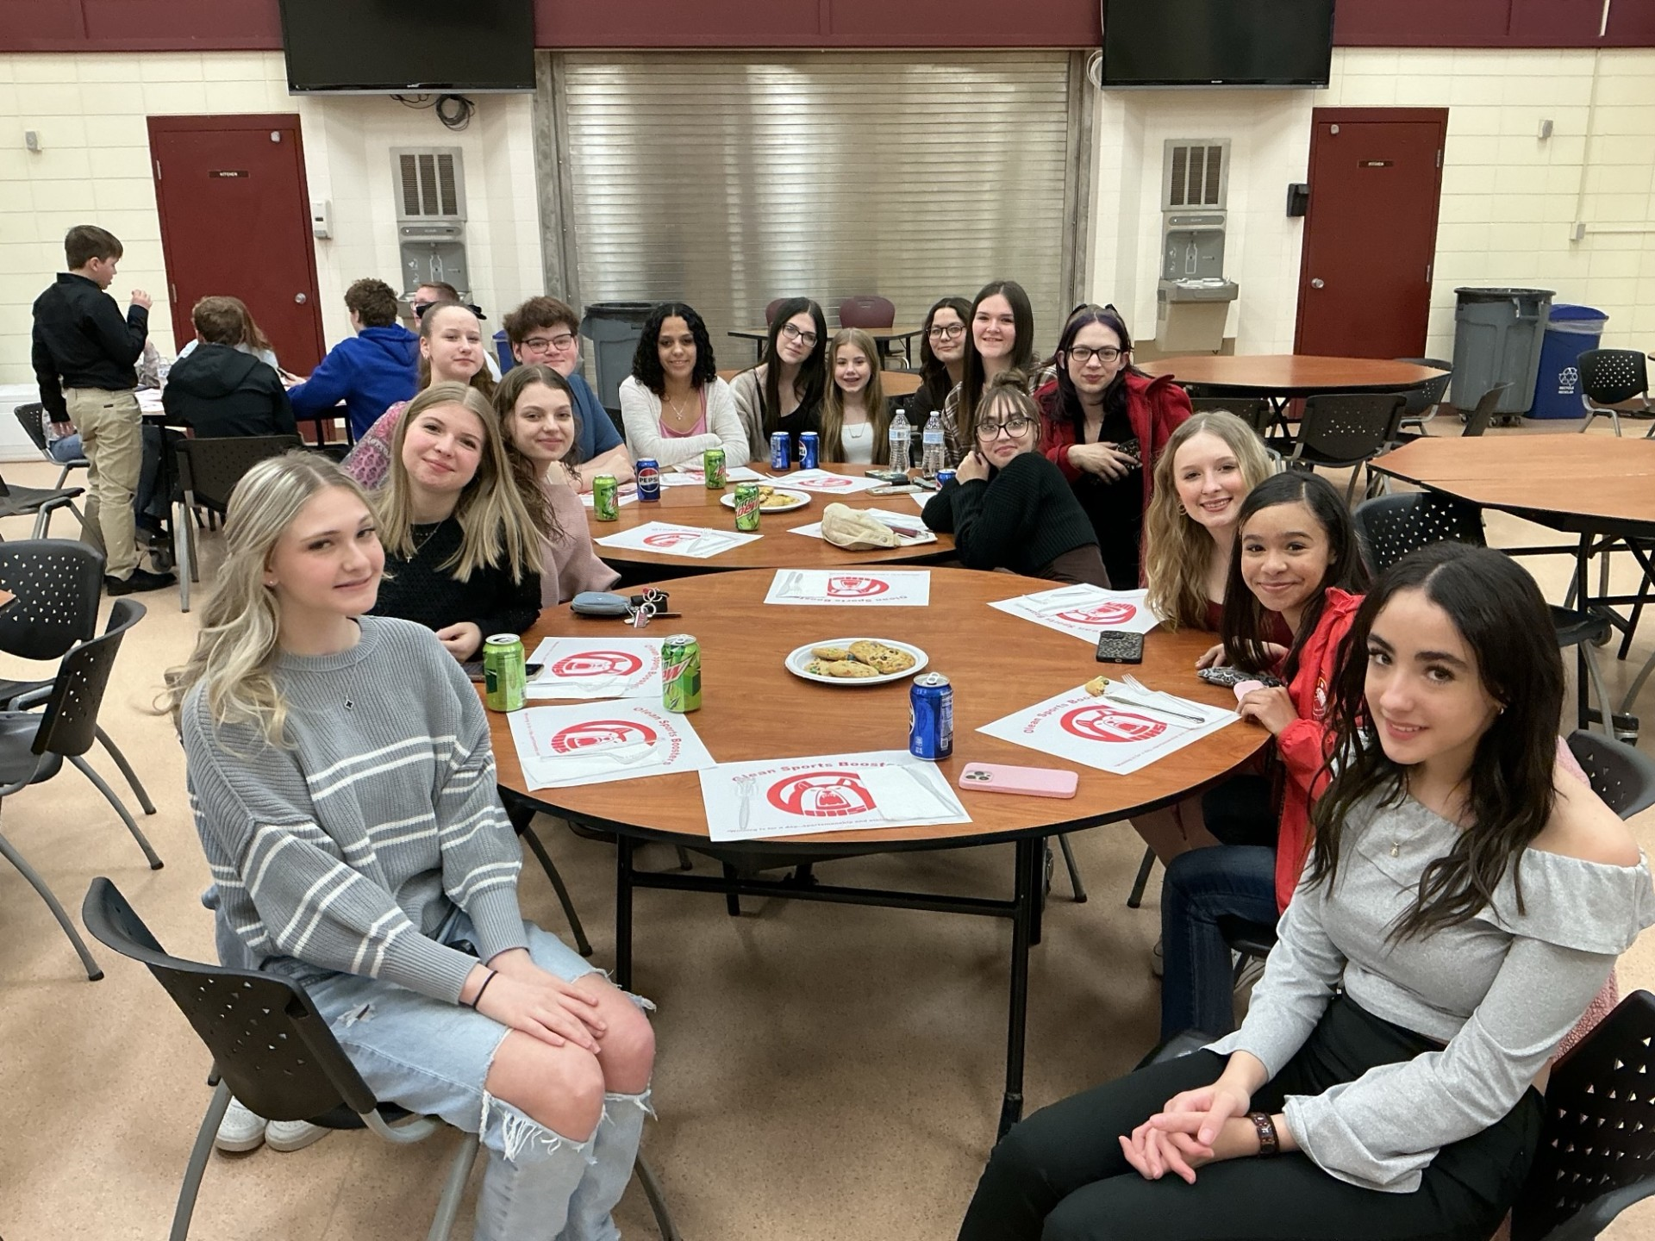
Winter Sports Banquet
Keep scrolling for more pictures!
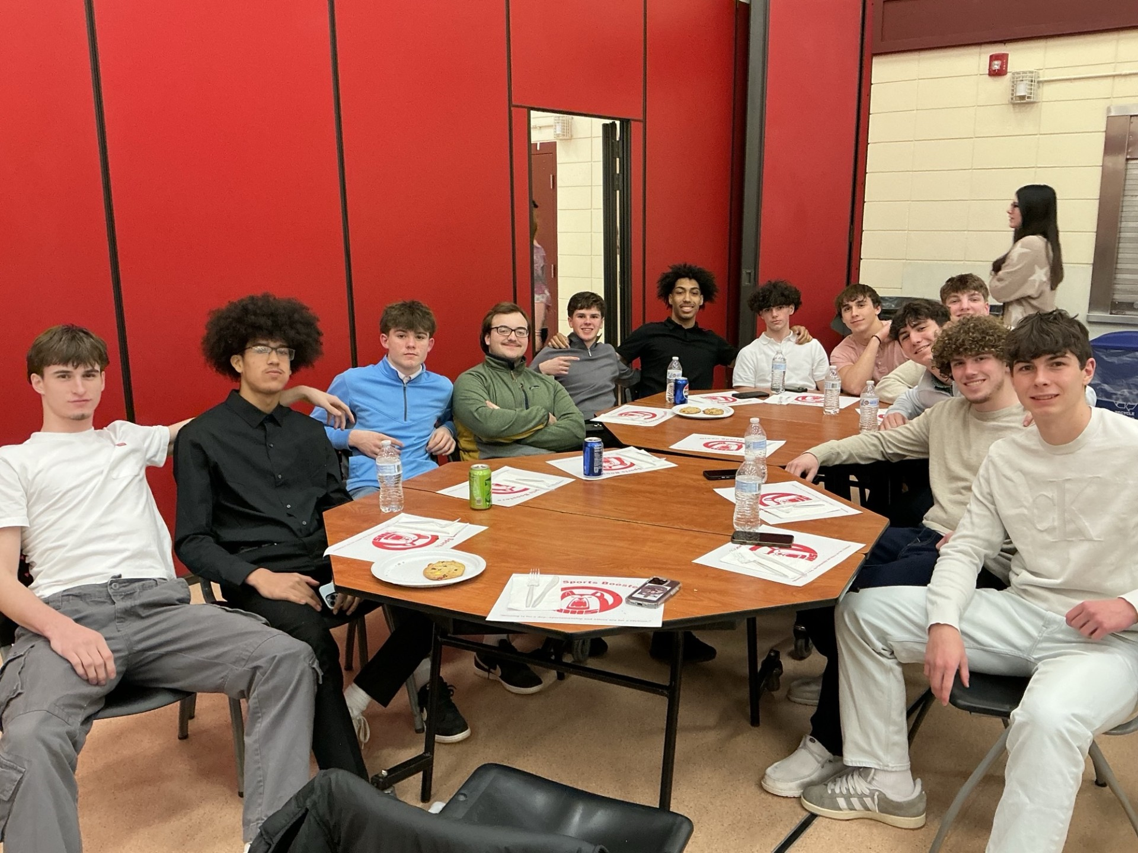
Winter Sports Banquet

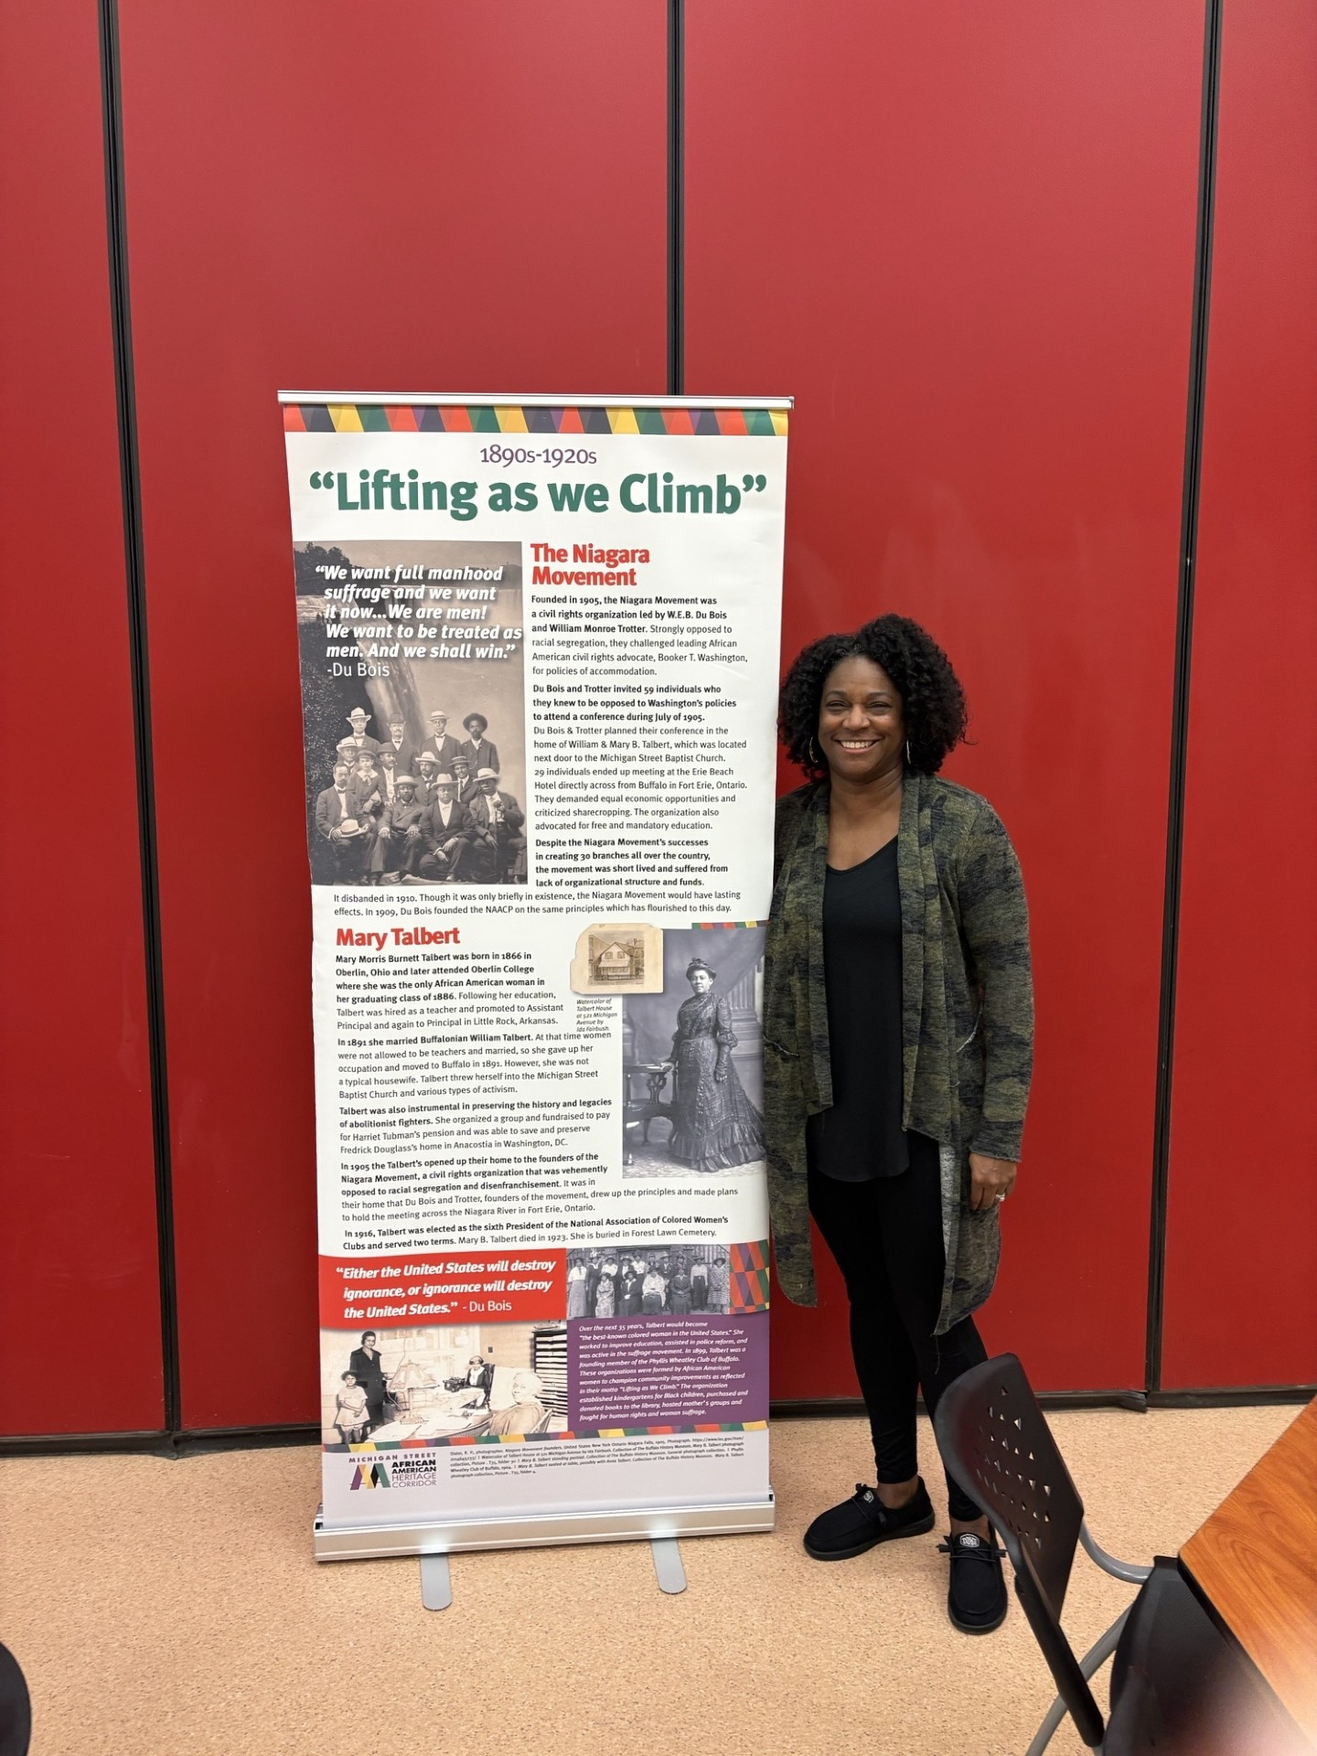 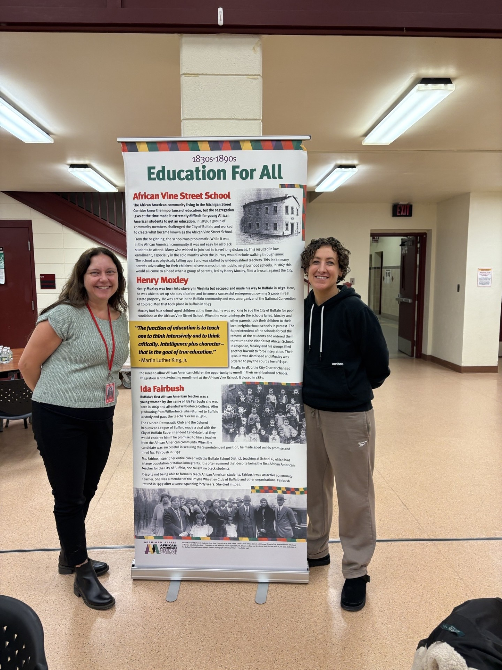 ( Tour)

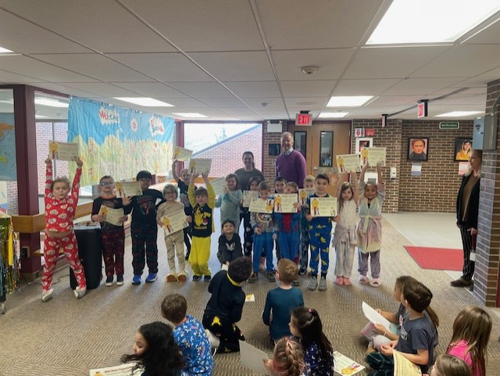 EV Celebration
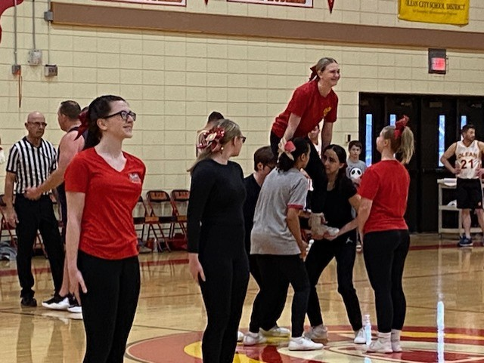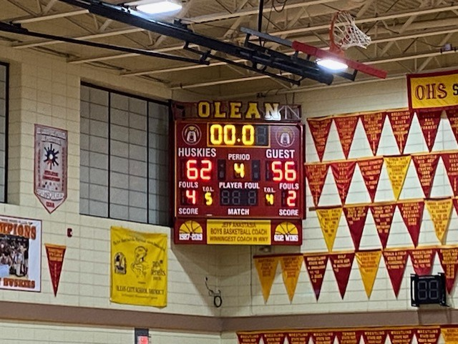
(OCSD vs. OPD Basketball Game)
Keep scrolling for more pictures!

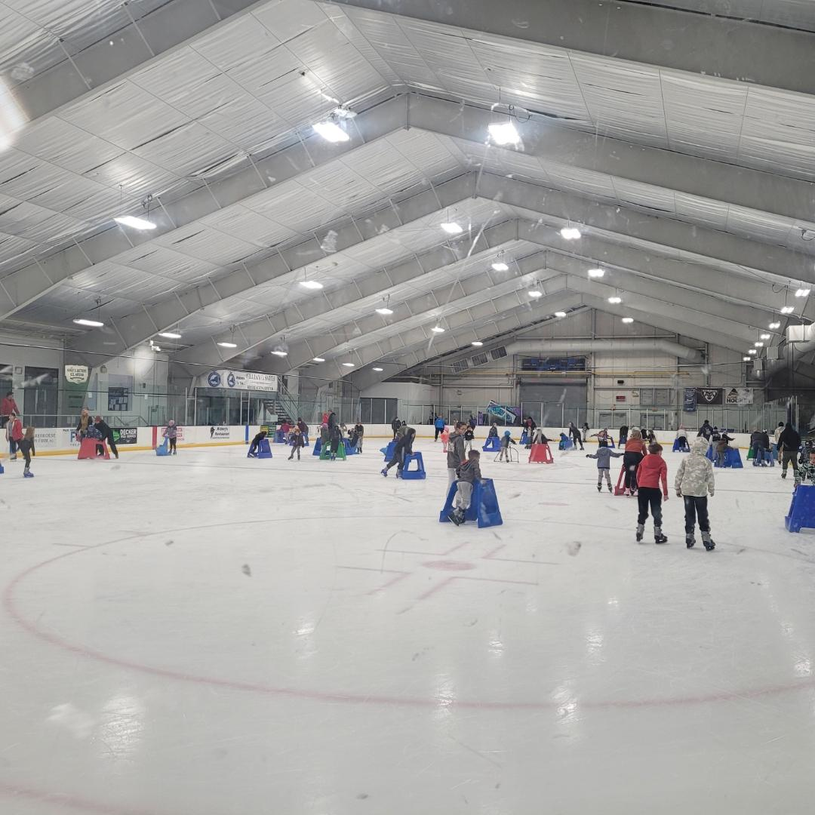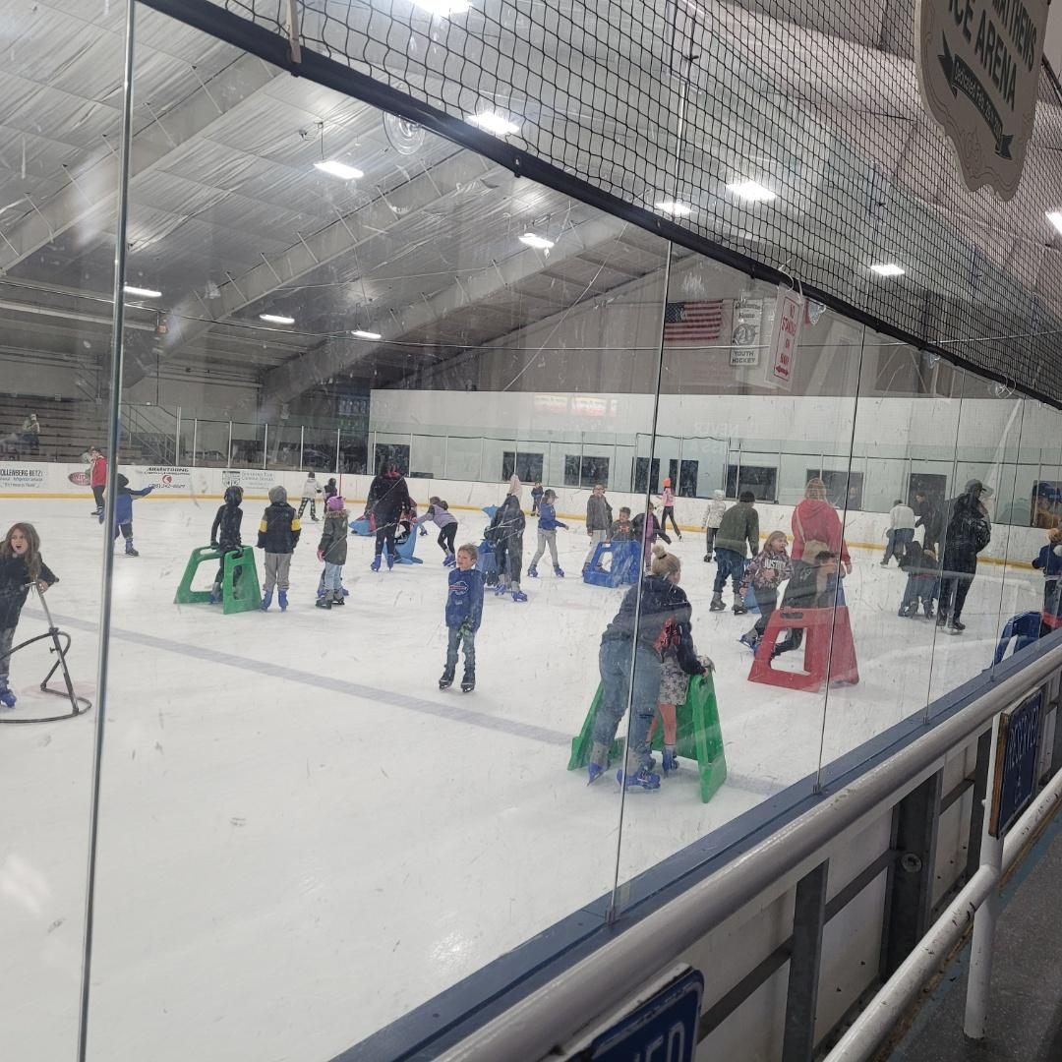
(EV Family Skate)

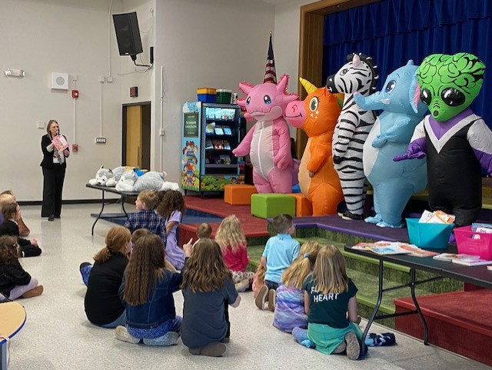 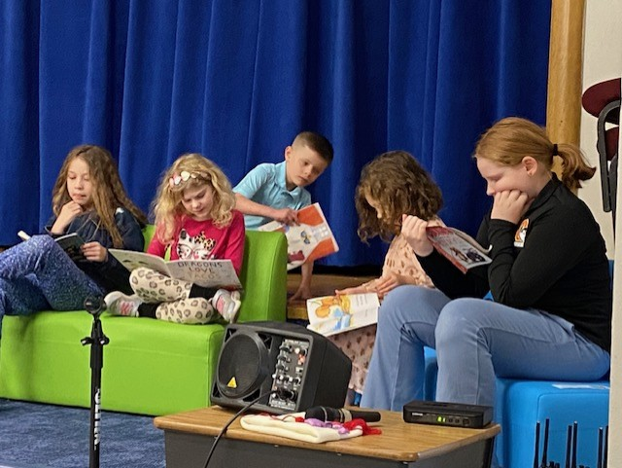(WW Masked Reader Night)
Thanks for Reading about all our wonderful events!

