Wednesday (10/7)

**//-//-//-//-//-//- //-//-//-//-//-//- //-//-//-//-//-//- //-//-//-//-//-//- //-//-//-**

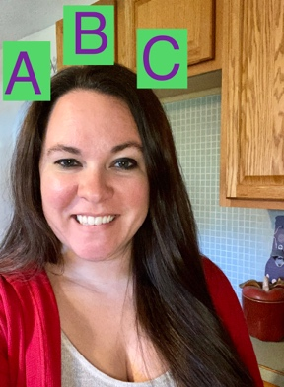

Literacy with Mrs. Acosta

* Repetition is great for our Pre-K students. We will repeat this all week. This week we are learning about the letter D. Check out the [D song](https://www.youtube.com/watch?v=Xf3MsJDsOLk) by PinkFong and this [Leapfrog letter sound song](https://www.youtube.com/watch?v=neItURLvyIQ&t=316s)
* Can you find something that starts with a D? Send your teacher a picture if you do!
* Here is a cute story about a dog looking for a place to live. [Click here](https://www.youtube.com/watch?v=an4jAjfJKe4)

Math with Miss Geary

* + Let’s play a counting game! [Click here.](https://www.education.com/game/counting-in-the-kitchen/)
  + Learning how to match is important! [Click here.](https://www.education.com/game/match-sight-words/)

Explore with Mrs. Abdo

* + [Learning about the color BLUE](https://www.youtube.com/watch?v=IJsXV51U3O8&t=29s) (click onunderlined)
  + Find 4 things in your house that are BLUE. Tell a family member what they are or send a picture to your teacher.
  + [Squares](https://www.youtube.com/watch?v=F877XKoi6Y0)
  + A square has how many sides? Tell your family or show them. Build a square with blocks, crayons or sticks, does it have 4 sides?

*Use below if you have NO technology *

Wednesday (10/7)

**//-//-//-//-//-//- //-//-//-//-//-//- //-//-//-//-//-//- //-//-//-//-//-//- //-//-//-**

Literacy with Mrs. Acosta

* Practice saying the letter Dd sound 10 times
* Can you find something in your home that starts with the letter D? Send a picture to your teacher when you do!
* Read with a family member.

Math with Miss Geary

* Explore with Mrs. Abdo
  + Find 4 things in your house that are BLUE. Tell a family member what they are or send a picture to your teacher.
  + A square has how many sides? Tell your family or show them. Build a square with blocks, crayons or sticks, does it have 4 sides?