**Olean Intermediate Middle School**

**2024 – 2025**

**7th Grade Supply List**

Dear (almost) 7th Graders,

Welcome to your last year at OIMS! We look forward to helping you make your 7th grade year a success. Please use the **shopping list** to help purchase your supplies. Enjoy the rest of your summer and know that your 7th grade teachers are excited to meet you!

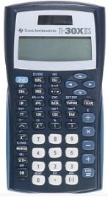

|  |
| --- |
| **School Supply Shopping List**   * **pens** (blue or black ink) * **pencils** * pack of four (4) **highlighters** * two (2) **loose leaf paper packs** * five (5) **2-pocket folders**   We recommend buying a couple extra for wear and tear.   * two (2) **1.5” three ring binders**   *If you are taking accelerated math, you will need a third binder.   * two (2) **composition notebooks** * two (2) **spiral notebook** (1 subject, 3-hole punched) * one (1) pack **plastic page protectors** (25-50 count) * **earbuds/headphones** * **TI-30XIIS Scientific Calculator** (as pictured) *optional |

The above list will help you get what you need for the school year. Please have extra pens and pencils. Students tend to go through a lot of these throughout the year and should keep a good stockpile in their lockers. Teachers will help you get organized once classes start. If you have any questions or concerns about what supplies you need, just hold off and know your teachers will give you time to get everything you need during the first couple of weeks of school.

Sincerely,

The 7th grade teachers