**Family Engagement News**

**by: Cindi Rhoades**

Happy Summer! I hope every family is taking time to spend some great quality time together and have some fun. I myself will be spending the month of July down South with my children, grandson, and extended family. I will be checking my emails periodically throughout July, but I will not get my voicemail until I am back to work on August 5th. Feel free to call and leave me a message but if you need a faster response from me, email me at [crhoades@oleanschools.org](mailto:crhoades@oleanschools.org) or message me through Parent Square. If you have general questions about Community Schools or our Summer STAR program, feel free to contact Amy Baer-Weis at (716) 375-8046 or Jen Mahar, Director of Special Programs, at (716) 375-8039.

We had a lot of awesome events towards the end of the school year at each of our buildings, a few things going on over the summer, and are making plans to bring in more family engagement type activities for the 2024-25 school year. 1st and foremost is the **FREE Family Haircuts** going on tomorrow (July 2nd) and Wednesday (July 3rd), at the Olean BOCES Center on the Windfall Rd in Olean. No appointment necessary as walk ins will be accepted between 9AM and 1:30 PM. Get your summer haircuts now! The **Summer STAR** program is back for current students Kindergarten through 5th grade and is running from July 8th through August 2nd, 5 days a week from 8:00AM to 12:15PM. For those that need transportation, we’ve got you covered! A breakfast snack and a full lunch are provided daily. If you are a family that participated in our Back Pack Program this past school year, and your child is attending the STAR program, we will continue to send food home on Fridays. The students will have a wonderful show planned for the public on the last day of programming, so stay tuned about this!

**Kindergarten and Pre-School screenings** will be taking place on July 23rd, 24th, 29th, 30th & 31st, as well as August 6th, 7th, & 26th. If you haven’t already, call Jacki Falk in Central Registration at (716) 375-8998 to register your child and schedule a screening. Registration can be completed by stopping by our Central Registration Building at 402 North 7th Street in Olean, Remember, bring in 3 proofs of residency, your child’s birth certificate, and any custody papers. You can also email Jacki with any questions at [jfalk@oleanschools.org](mailto:jfalk@oleanschools.org).

**East View** held their last Character Assembly for the year and had 65 family members come in to celebrate the students. They had their Pre-K graduation (see pictures) and 143 family members got to experience this special occasion with their littles. New this year, East View also held a 3rd Grade Moving Up ceremony where 127family & friends joined them to mark the sad yet exciting event of leaving East View and heading to OIMS in the Fall. On **August 29th,** East View will have an Open House for students and Parents, so stay tuned for more information to follow on this. We will also continue to offer the Back Pack Program this coming school year.

**Washington West** held theirPre-K graduation on June 18th, and had 98% family participation! They also held their annual 3rd grade moving up ceremony where 141 family & friends came to witness this sad yet exciting event of leaving Washington West and heading to OIMS in the Fall. They also recognized 8 students with the Tyler Bihler Award. (see pictures) On **August 29th,** Washington West will have an Open House for students and Parents, so stay tuned for more information to follow on this. We will also continue to offer the Back Pack Program at Washington West this coming school year.

**OIMS** held their Track & Field Day where tons of people came out to watch the students do their best. Everyone had a great time! Then there was the 7th Grade recognition Ceremony on June 25th where over 250 people came to celebrate this event. (see pictures) **New this year:** OIMS will be having their first annual 4th grade Student & Family Orientation Night on **August 26th from 6-7** PM. We are so excited to get this started for the 2024-25 school year, and strongly encourage all incoming 4th graders and their parents/guardian to attend this amazing event! Then of course OIMS will have their annual Open House for grades 5-7 on **September 3rd,** so keep an eye out for more information on these events. I can’t stress enough how important it is for your child’s success, to get and stay involved in school activities, especially as they get older and more independent.

**OHS** hosted the BOCES graduation in June so the seats in their Auditorium were filled with not just family and friends of Olean students, but also other school district graduates that attended an Olean BOCES program. What a way to bring everyone together to celebrate their accomplishments! They also had the “Avenue of Graduates” in downtown Olean where seniors stood by their picture flags, and everyone drove or walked by to congratulate them. And of course, we always have a huge turnout for the Graduation ceremony which was held on June 22nd. Upcoming opportunities for Family Engagement at OHS will be the 2nd annual 8th Grade Student & Family Orientation Night on **August 27th from 6-8 PM**. I would love to see 100% of the families come in for this special and very informative event. This will be for all incoming 8th graders and their parents/guardians. School starts on **September 4th** and OHS will have their annual Open House that evening, so keep an eye out for more information on these great events!

The **Special Education** Team has several new things going on which would include some walk throughs of their new classrooms over this summer. If you are a student with a disability and are an incoming Junior or Senior, and you haven’t yet filled out your paperwork for ACCES-VR (transitional services),we will have a Junior/Senior & Parent Night to help with this on **October 9th from 6-7 PM** at the PLC (Central Registration) 402 N. 7th Street. Paperwork for this will be sent out in September. If you would like to fill the application out before that, just give me a call at (716) 375-8031. We have also planned to bring in at least two workshops from Parent Network, one scheduled for **October 16th** and one for **March 12th.**

The Olean City School District is pleased to announce that we are working on bringing a free dental clinic to all our buildings and expanding our Back Pack Program. We are also very excited about two huge events we are planning. The first is our 2nd annual **Welcome Back** event on **September 21st** which will be open to all students and their families as well as any community members. This is a free event to showcase the many resources we have in the area and how important you all are to us! Next, we will have our annual free **Community Thanksgiving Dinner** on **November 16th** so mark your calendars! We will continue to offer several parent engagement activities this coming school year. I can’t stress enough the importance of the community as a whole interacting with the school and getting involved! Board of Education (BOE) meetings are held at least once a month and all community members are encouraged to attend these meetings and have a say in policies, practices, budgets, etc.

**SAVE THE DATES:**

**Monday August 26th 6-7 PM OIMS 4th Grade Student & Family Orientation Night**

**Tuesday August 27th 6-8 PM OHS 8th Grade Student & Family Orientation Night**

**Thursday August 29th EV & WW Open Houses**

**Tuesday September 3rd OIMS Open House**

**Wednesday September 4th- School Begins for all students**

* + - * + **Open House Night at OHS**

**Saturday September 21st – Welcome Back Community Event**

**Wednesday October 9th- 6-7 PM ACCES-VR Night**

**Wednesday October 16th- 6-7:30 PM Parent Network Workshop**

**Saturday November 16th- Community Thanksgiving Dinner**

Did you know that there are plenty of resources available on our website? Just go to **www.oleanschools.org** and under the **Community Schools** you will find the **Family Engagement** Page. Here you will find plenty of resources and we will continue to update these. There is also a **Calendar** and a **Community Events** section that includes both things through the school and a section for events out in the community for families toparticipate in! New items are listed almost daily so check it out. We also added a section for **Newsletters** that will be posted monthly. Also, there is a family resource page for each of our buildings through Parent Square. If you know of an event in the community and don’t see it listed there, feel free to contact Cindi Rhoades at (716) 375-8031 or [crhoades@oleanschools.org](mailto:crhoades@oleanschools.org) and fill me in.

**Enjoy the pictures below of some events we had in June!**

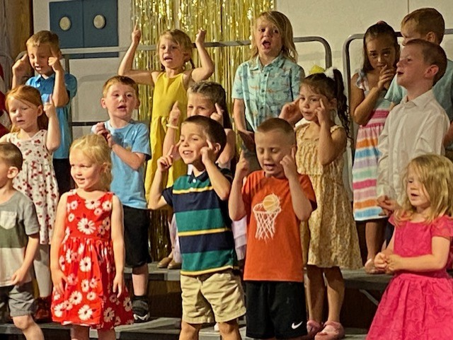 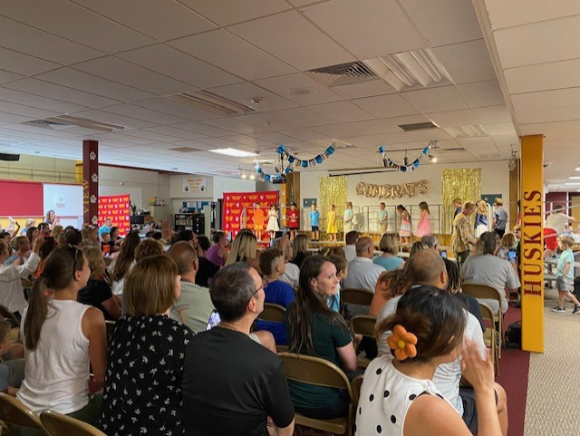

East View Pre-K Graduation East View Pre-K Graduation

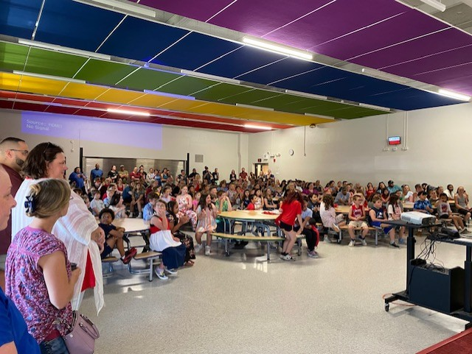 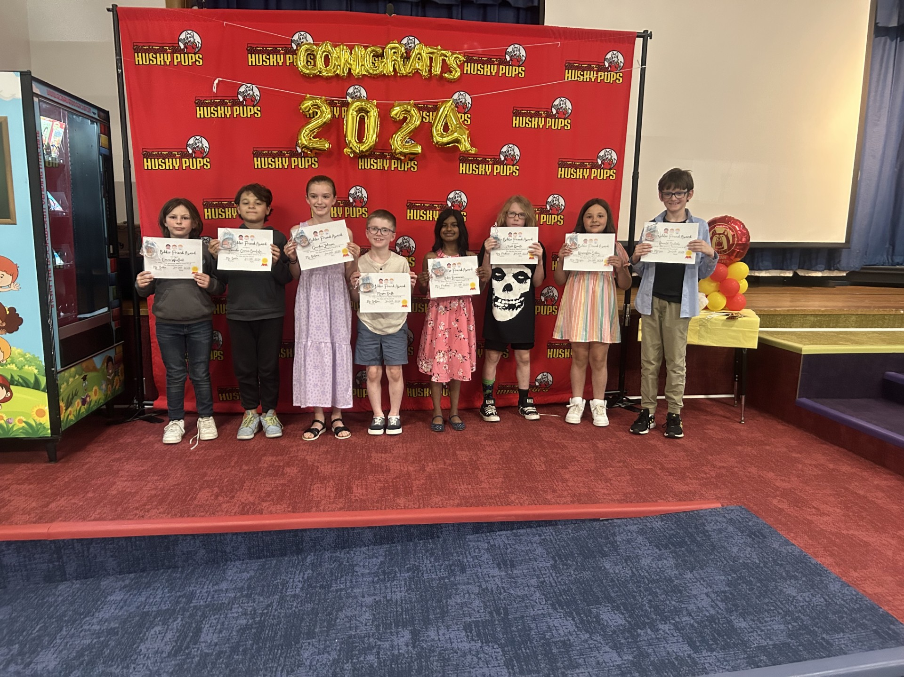

Washington West 3rd Grade Moving Up WW- Tyler Bihler Award Winners

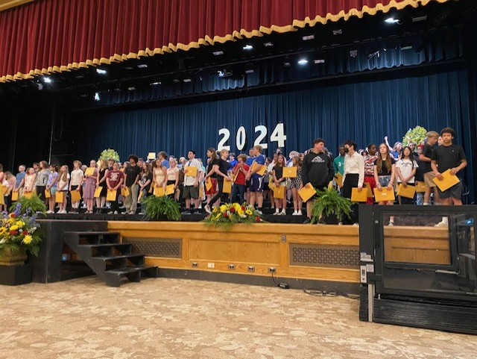 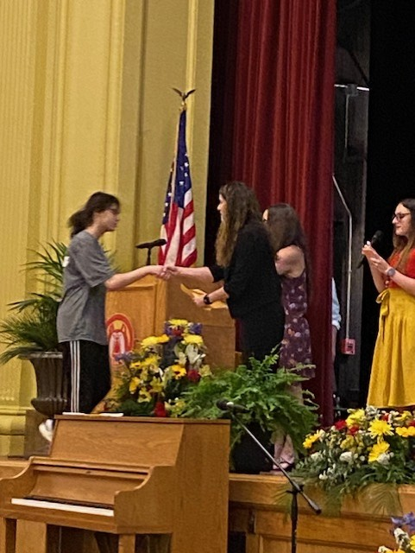

OIMS 7th Grade Recognition OIMS 7th Grade Recognition